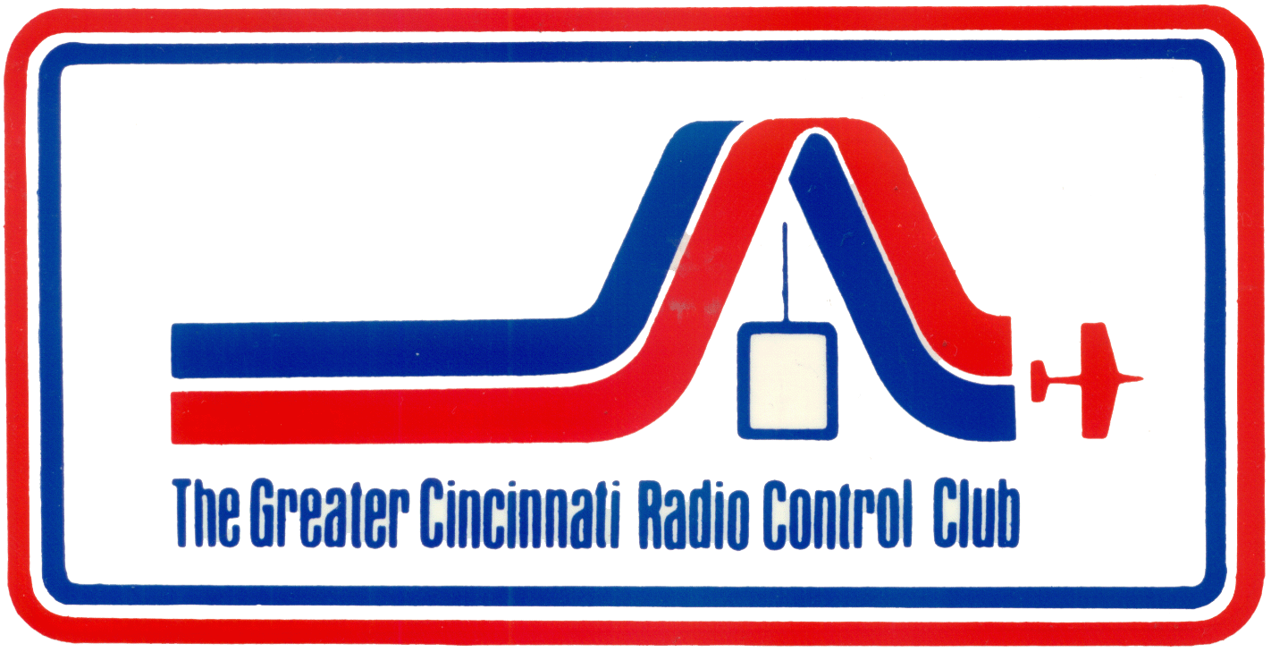

WELCOME TO THE GREATER CINCINNATI

RADIO CONTROL CLUB

STUDENT HANDBOOK

2006 Revision Incorporates Editing from Ken Simms
2005 Revision Incorporates Revised Rules
2004 Revision Edited by Richard Kuns
1999 and 2003 Versions by David Polley
With contributions from many GCRCC Members

FOREWORD

Welcome to one of the most exciting hobbies available. The art of flying a radio controlled model aircraft can be very rewarding as well as challenging to the novice flyer. At first you may have been somewhat overwhelmed with the strange terminology and all the gadgets available when you first became interested in this hobby. But now you have a plane, a radio, and are ready to begin learning to fly.

The purpose of this handbook is to help you learn the skills and expectations in order to become a safe, proficient model pilot. You will find much information in this book that will guide you.

Please keep in mind, that of all the aspects of this hobby, SAFETY is paramount and must be the primary consideration for all of us, all the time. We can never take safety for granted. You are responsible for your actions as well as for your model. Keeping a level head at all times can save you grief as well as protect those around you.

Training can be very hectic at times with the concurrent activities of many students, instructors and ground crew. For your and other’s safety, pay attention to the situation and follow all directions from the staff. Make sure everyone is aware of your intended actions.

Alcoholic beverages are not permitted on the flightline or in the pit area during training. This rule applies to everyone!

The instructors who will be training you are of the most qualified and experienced pilots in our club. These volunteers are donating their time, as well as their experience and will teach you the fundamentals necessary to solo your model. Please be patient with them as well as yourself. It takes time, constructive criticism and practice to become a good pilot. Our objective is to help you perfect your skills and acquire the confidence you will need to fly safely on your own.

We wish you the best of luck as you progress with your training and hope it will be for you, what it has been for us - fun, challenging, and rewarding.

The Greater Cincinnati Radio Control Club
TABLE OF CONTENTS

FOREWORD i
GCRCC RULES 1
SETTING-UP YOUR MODEL 4
SAFETY 6
PREPARATIONS FOR INSTRUCTION 8
FIELD ETIQUETTE 10
ENGINE MAINTENANCE 11
LANDING 13
GLOSSARY 18
PRE-FLIGHT CHECK LIST 20
INSTRUCTION PROGRAM 21

GCRCC RULES

Approved by GCRCC Board 2/10/05
Flight Rules

- All pilots must comply with the AMA Safety Code. This code is posted on the bulletin board at the field and can be found in the AMA Membership Application.

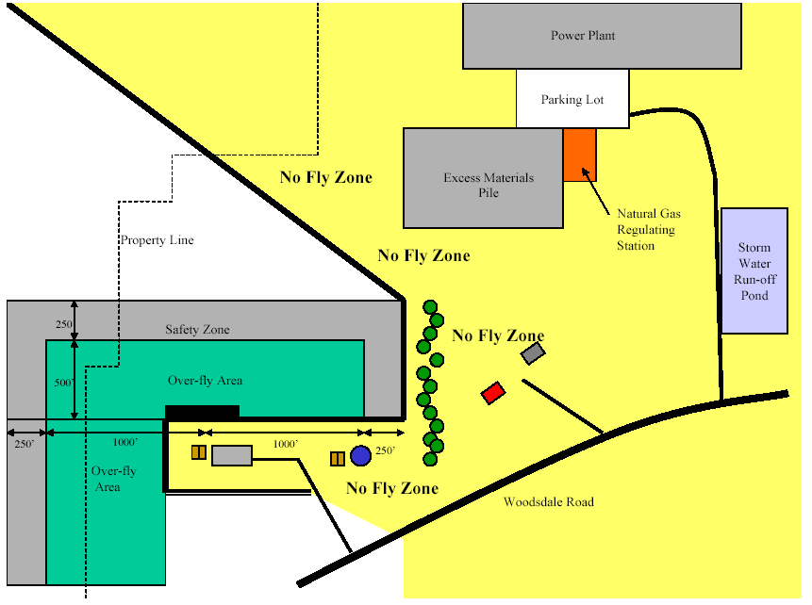

- All pilots flying aircraft at the GCRCC Field must obey the boundaries of the field and avoid the "NO FLY ZONE". Respect the eastern field boundary to avoid over flight of our neighbor, the Chrisholm Historic Farmstead.
- Engines may not be started in the pit area unless the pilot has the proper frequency pin, and the airplane is pointed in a safe direction and properly restrained. Prop wash should not be aimed at other planes or people. Insure that all people are behind propeller before the engine is run up to full throttle.
- When flying from the paved east-west runway, flying south of the runway is not permitted except for emergencies. When flying from the unpaved north-south runway, flying east of the runway is not permitted except for emergencies. Flying over the pit area is never permitted. Pilots must stand on the marked pilot line when flying on paved runway or a mutually agreed upon line when flying on the unpaved runway.
- A pilot should announce his intentions prior to carrying or taxing a plane to the runway, taking off or landing. Dead stick landings should be announced and have preference over other operations. To retrieve aircraft stopped anywhere in front of the pilot line, walk behind other pilots to a point closest to the aircraft and announce intention before crossing the pilot line onto the runway.
- Take offs and landings should be made into the prevailing wind. In the event of a cross wind or no wind, the active pilots should agree on a direction.
- High-speed low passes should be made beyond the runway.
- No flying may occur while the field is being mowed without prior consent of mower operators.
- A pilot about to make a "maiden" flight or the first flight after repair must inform the others on the flight line and in the pit area. This ensures that everyone is alert in the event of a problem.
- New members and students are not permitted to fly at the GCRCC field unless they are under the direct supervision of a GCRCC instructor or have been "signed off" by two GCRCC instructors.
The board appoints instructors for each flying season upon the recommendation of the training coordinator.
- Non-members may fly at the GCRCC field as the guest of a current member or as part of a GCRCC sanctioned event. Proof of current AMA membership is required.
- Non-AMA members may receive one demonstration flight with a buddy box under the control of a GCRCC instructor. The plane must be owned by a GCRCC member.
- When frequency control pins are in use, you must have the proper pin in your possession before you turn on your transmitter. When you pick up the pin from the rack, place your GCRCC Membership Card in its place. Return the pin to the rack after your flight and after your transmitter has been turned off and remove your card. Note: When the pins are not in use, it is your responsibility to make sure your frequency is clear before turning on your transmitter.
Equipment Rules

- Channel number/frequency is required to be clearly displayed on all transmitters.
- Your name and address must be placed in your model, or your AMA membership number must be displayed on your model.
- Mufflers are required on all 2-cycle engines of .10 cubic inch displacement and larger. Mufflers must be an enclosed, expansion chamber type. Engines with tuned pipes are considered muffled. Engines that seem too noisy will be checked against AMA guidelines.
- A proper spinner or lock nut is highly recommended on all engines. The single nut and washer that came with your engine should not be used without a spinner or lock nut.
- All radio equipment used at the GCRCC field or sanctioned event must meet the 1991 AMA requirements.
- The GCRCC highly recommends that EZ connectors not be used on glow or gas powered airplanes for the control surfaces--rudder, elevator and aileron.
Site Rules

- All spectators must remain behind the spectator line at all times. Any small children must be accompanied by and under the control of a supervising adult.
- The last person to leave the field is responsible for locking the front gate. The GCRCC combination lock must be connected between the chain and the Cinergy pad lock. Please be sure the lock is reset to read 0-0-0-0 at all times.
- The picnic facilities are for use by Cinergy Woodsdale Power Plant employees, GCRCC members and their immediate families and guests.
- No glow or gas powered boats on the pond.
- No models, flight boxes and/or equipment are permitted on the tables in the Cinergy shelter.
It is your responsibility to remove your trash and leave the field clean.
SETTING-UP YOUR MODEL

Before your model is flown for the first time, it will be checked out by the instruction staff to make sure it is safe to fly. Here are some things you can do in advance to prepare your model.

1. Check the model carefully for any warped or twisted surfaces. These should be removed before the model is flown. If you need help correcting them ask for it.

2. Balance the model so that it is slightly nose heavy when held at the recommended balance point. Balancing is done with an empty fuel tank. If balance cannot be achieved by moving the battery, add nose or tail weight as necessary.

3. Make sure that all hinges are secure and that there is no binding of the control surfaces through their full range of movement. Control linkages should be set for the amount of throw recommended by the manufacturer of the model.

4. Mount the receiver switch on the side of the model opposite from the muffler. This is so that fuel residue does not get into the switch and cause a failure.

5. Be sure to thoroughly fuel proof any wood surfaces that may be exposed to fuel. This includes the engine compartment and the fuel tank compartment. For fuel proofing, mix slow cure epoxy with a little alcohol and brush it onto all exposed surfaces.

6. Be sure the nose wheel is straight. To check this, with the plane on a hard, flat surface and the radio on - push the plane. If it does not roll in a straight line, adjust the nose wheel until it does. Also, don't put too much throw in the nose wheel linkage. An 8 - 10 foot diameter circle at full throw is adequate. Too much throw makes the plane difficult to taxi.

7. Adjust the throttle linkage so that with the trim lever in the center position, at full throttle (aIl the way forward on the left hand stick) - the barrel in the engine carburetor is fully open and at low throttle there is just a slight opening - enough for the engine to run at idle. Then by moving the trim lever down, the gap should disappear which will stop the engine. It is very important that you be able to stop the engine with the trim lever as described.

8. Be sure your control surfaces are set-up with the correct servo direction. Here is a summary of what you should see when standing behind the plane:

Four Channel Set-up
Left Hand Stick Up High Throttle
Down Low Throttle
Right Rudder swings right, nose wheel points right
Left Rudder swings left, nose wheel points left
Right Hand Stick Up Elevator moves down
Down Elevator moves up
Right Right aileron moves up, left aileron moves down
Left Left aileron moves up, right aileron moves down

Three Channel Set-up
Left Hand Stick Up High Throttle
Down Low Throttle
Right Not operative
Left Not operative
Right Hand Stick Up Elevator moves down
Down Elevator moves up
Right Rudder swings right, nose wheel points right
Left Rudder swings left, nose wheel points left

SAFETY

The single most important topic that you must have on your mind at all times while flying is safety. We must not take safety for granted either for our own sake or for the sake of those around us. Consider that your model is capable of flying in excess of 80 mph and that your engine is capable of turning your propeller in excess of 15,000 rpm. There is no place for negligence, carelessness, or the excuse of not thinking clearly. Please read the following information carefully and use good judgment and good sense.

A. ENGINES AND PROPELLERS

1. Use a safety stick or an electric starter to start your engine. Do not use your finger. A spinning propeller can remove a finger or sever an artery. Also, do not use a metal object such as a screwdriver. If the engine kicks, the propeller could be nicked making it unsafe. Pay close attention to this rule and save yourself a quick trip to the Emergency Room.

2. Do not start your engine while someone is standing in line with the propeller. Propellers can break.

3. Do not reach over the propeller to remove the glow battery or adjust the needle valve. Move behind the engine to make all adjustments once it has started.

4. Be careful that you do not let anything get in the way of a spinning propeller - this includes transmitter antennas, items from your shirt pocket and clothing such as ties or shirt sleeves.

5. Always balance your propellers to minimize vibration and it is a good idea to paint the tips of your propeller with a bright color. A spinning prop can be difficult to see. If you use a fiberglass or nylon propeller, lightly sand the edges as they can be razor sharp.

6. Use either a safety hub or a spinner on your propeller.

7. Each time you fly, check that the engine mount is securely fastened to the fuselage and that the engine is securely fastened to the mount.

8. Make sure that the engine can be stopped with the trim lever on your transmitter.

B. RADIO EQUIPMENT

1. Do not turn your transmitter on unless you have the frequency pin for your channel or have verified that your frequency is clear. You do not want to cause someone else's plane to crash.

2. Make sure that the servos are not binding, jumping, or buzzing. Correct an improper installation or, if necessary, replace the servo.

3. Make sure the receiving antenna is extended outside the plane for best possible reception. Do not, under any circumstances cut or knot your antenna. The antenna provided is the length it needs to be for proper performance of your radio.

4. Wrap both your receiver and your battery in foam and place them in plastic bags to help protect them from vibration and moisture. Do not place the battery alongside the wires connecting the servos to the receiver. This can cause interference.

5. Never tamper with the electronic components inside your receiver or transmitter. If repairs are necessary, send it to a qualified repair service.

6. Charge your batteries fully before you come to the field. The batteries require 14-16 hours to become fully charged. Don't risk your plane and other's safety by using run down batteries.

7. Always ground check your radio before a "maiden'' flight or after a repair. With the radio turned on and the transmitter antenna not extended, walk 50-75 yards away and confirm that all controls work properly. lf the servos jiggle or jump without your moving the sticks, find the cause and correct it before you fly.

8. Replace any wire that has been nicked or if any insulation has been removed. Your radio could stop functioning at any time, or a shorted battery could start a fire.

9. When you arrive at the field, please be sure that your transmitter has been turned off so that you don't "shoot down'' a friend as you are driving in.

C. INSTALLATION & PRE-FLIGHT

1. Install each servo horn perpendicular to its pushrod - unless otherwise indicated in the planes set-up instructions. Be sure to install the screws that hold the servo horns in place. It is really easy to forget this after you have made adjustments.

2. For all control surfaces, use a pushrod with a threaded clevis on one end and a "Z" bend on the other. Do not use a threaded clevis on both ends and do not use EZ connectors.

3. Don't skimp on rubber bands to hold the wing in place. Use at least twelve bands - four on each side and two crossed from each side. Also, don't save the rubber bands. They will rapidly deteriorate in sunlight and with exposure to fuel or its exhaust.

4. Do a brief pre-flight inspection before each flight. Check that the hinges are secure and that the controls are all working and moving in the proper direction. Check that the propeller is not split or nicked - if it touched the runway on your last flight, it may have to be replaced. Check that the engine is secure. If the last landing was rough, check that the wing and tail surfaces are not loose or broken. Check that the trim levers are in the proper position.

5. Make a note at the end of the flying session of any adjustments or repairs that are needed and be sure they are complete before you come to the field again.

6. Once your plane has been trimmed, adjust the linkages so that the trim levers on your transmitter are centered. Then you won't have to remember the correct setting for each of them - and you won't get a surprise if someone inadvertently moves a trim lever.
PREPARATIONS FOR INSTRUCTION

1. Always charge your batteries before a training session. Remember it takes 14-16 hours to fully charge the batteries. Equipment is available for "fast charging'' or for "cycling" the batteries. It is advisable to periodically allow a battery to discharge to a certain point before recharging. This prevents the battery from establishing a "memory." The "cyclers'' available do this plus they tell you how much capacity you actually have. A "trickler" is also available. This allows you to charge your batteries and then hold them at peak charge condition indefinitely. That way you are always ready to go flying. An Expanded Scale Voltmeter is also a good investment. This tells you the condition of your battery under load and can quickly answer the question, "Do I have enough charge left for one more flight?"

2. Be sure to bring the proper tools and equipment with you to the field. Here is a suggested list:

Fuel Extra propellers
Fuel pump Prop wrench
Extra fuel tube Prop reamer
Extra glow plugs Rubber bands
Glow plug wrench Razor knife
Glow plug battery C/A adhesive
Screwdrivers Pliers
Electric starter or safety stick
Allen wrenches or ball drivers (sizes needed for wheel collars, etc.)
AMA Membership Card
GCRCC Membership Card
Instruction Handbook

Instruction is held from 6:30 until dark on Monday and Wednesday evenings - April though September. Be sure to check the Flightline Newsletter each month for any variations in this schedule.

When you arrive at the field, you will be asked to sign-in so that instructors can be assigned in rotation and everyone will have an equal opportunity to fly. Get your plane put together and fueled quickly and perform a pre-flight check so that you will be ready when called. As part of you pre-flight it is recommended that you also do a ground check of your radio. (See "SAFETY,'' item B-7 for specifics.)

Each training flight lasts about 12 minutes. You will be taught maneuvers in the same order as they are presented in the Student Progress Sheet (the last page in this handbook). The instructor will rate your performance and will sign-off each step when he thinks you are ready to move on. The objective of the training is to teach you to handle the plane safely from takeoff to landing. So be patient, it takes time to develop the skills and confidence necessary and you will have fun doing it.

It will help you get started if, when you show-up for training the first time, you have already run the engine. Most 40 and 60 size model engines do not require an extensive break-in and can be flown right out of the box. However, using the following procedure will help assure a smooth running engine: engine parts have a chance to wear-in without the engine overheating. (lf you drip fuel on the engine cylinder and it fizzles, the engine is too hot.) If you are bench running your engine, make sure it is plenty rich and open the throttle. The engine should be in “4-cycle'' mode and be spitting out lots of smoke. Do not let the engine rev-up to “2-cycle'' mode and begin to “scream” until after at least half a tank. Then lean it out briefly—10 seconds or so—and then return to a rich setting. If the engine is mounted on the plane, follow the same procedure except make sure the model is securely tied. If the engine shows signs of overheating, shut it off and wait for it to cool, the repeat the process. If you have any questions about this break-in procedure, bring your plane to the field and ask for help. If you treat your engine properly, it will last for a very long time.

After the first tank full, if you have a suitable place, you ran practice taxiing your model--do this without the wing attached so there is no danger of a takeoff. Be aware that when the plane is coming towards you, the steering control is reversed—you push the stick left to turn right! It will take some practice to get accustomed to this. This same thing happens while you are flying. One way to help overcome this is to imagine yourself in the cockpit so that you stay in control regardless of which direction the plane is heading.

For the first few flights you will want to run the engine slightly rich. Tell your instructor how much the engine has been run.

To hold the transmitter, use the thumb and forefinger on each stick. Do not use just your thumb. A thumb can slip off the stick and cause a crash. Practice this correctly from the start so that it becomes automatic. Also, get used to holding the transmitter without the neck strap. During training a strap cannot be used as it is necessary to pass the transmitter between you and the instructor.
FIELD ETIQUETTE

1. We as flying members are well aware of your enthusiasm and eagerness to solo. We all went through the same experiences you are having. That is why we have established this instruction program ... so that you can safely learn what you need to know to be a proficient pilot. Be aware that instructors have his own style of teaching and of flying and you can learn from each of them. Take advantage of their hints and suggestions to find what works best for you. Eventually you will develop your own style and, hopefully, will be instructing others.

2. The published instruction schedule shows the times that are set aside for only instruction. It is possible for you to get additional instruction time at the discretion of an instructor. Feel free to bring your plane to the field on other evenings or weekends. If an instructor is present, ask if they will let you fly. However, you need to keep in mind that they came to fly their own plane and to socialize. They may not want to instruct then. So, please don't be discouraged if you are turned down.

3. When you are at the field stay alert to what others are saying and doing - especially if there are planes in the air.

4. Don't test run your engine in the pit area. This is very distracting to those flying, as they need to be able to hear their own engines. If you are breaking-in an engine or will be running it for any extensive period of time, take it to the area across the parking lot.

5. On a nice day there can be lots of spectators. Please help remind them to stay behind the fence. If you want to show them a plane or demonstrate the controls, get the frequency pin and take the plane out to the spectator area. Talk to our visitors. They also have an interest in our hobby and may wish to join our club. There is a supply of sheets in the impound shed that contain membership information and an AMA application form.

6. Any time you have a problem with your plane, engine, or radio—ask for help. There is a lot for you to learn and the other members of GCRCC are willing to help you. Take advantage of the knowledge and experience of others and ask lots of questions.
ENGINE MAINTENANCE

With a little care, your engine will give you many hours of flying enjoyment. Here are some tips to help keep your engine running smoothly:

- Place a fuel filter inside your fuel container or on the fill line of your fuel pump. This will keep small particles from entering your engine. Do not put a filter between the tank and the engine. This will eventually reduce the fuel flow and stop your engine—usually at the most inconvenient time!
- Don’t expose your fuel to air—keep the bottle capped. Model airplane fuel will absorb moisture from the air and quickly become useless. Also, don’t store your fuel in direct sunlight. The sun’s rays will eventually breakdown the fuel.
- Any residual fuel left in the engine after a day’s flying will attract moisture that will eventually rust the inside of your engine. After you have emptied the fuel tank, keep the fuel line disconnected and start the engine to burn any residual fuel. Then add “after run” oil through the carburetor and flip the prop a few times to distribute it throughout the engine. Several oils are available in hobby stores, but they tend to be expensive. An alternative is to mix lighter fluid with automatic transmission fluid in a 50-50 mixture. (A most effective procedure is to start the engine after adding the lighter fluid mixture. After a few seconds, all the moisture bearing fuel will be gone. You can then squirt some more of your mixture into the engine and it will be ready for storage.) Be sure to keep the fuel line disconnected until you are ready to fly again so that any fuel left in the tank is not drawn into the engine.
- Never run the engine at maximum possible RPM. The correct setting is about 500 RPM less that maximum. If in doubt “richer” is better than “leaner.” With the engine running at full throttle, hold the plane nose-up at about a 45 degree angle. If after a few seconds, the engine slows, it is too lean.
- The engine should transition smoothly from an idle to full throttle. If it tends to hesitate or stall, an adjustment of the low speed needle is probably needed. This should be done very gradually—an eighth of a turn at a time. (Note: If you have an engine with an “air bleed” carburetor—there will be a small hole on the front of the carburetor—the low speed screw will work the reverse of what you expect. Clockwise is rich, counterclockwise is lean.) Refer to the manufacturer’s instructions for specific information on carburetor setting for your engine.
- If the exhaust residue from your engine is black, metal particles are being rubbed off somewhere. You should find and correct the problem. Ask for help.
- Engine will perform differently with different fuels, props and glow plugs. Find out what has worked best for others with your engine.
- If the engine won’t run:
Is it getting fuel? Check for air leaks in the tank and fuel line.
Check for dirt or other obstruction in the carburetor.
Clean the needle valve assembly.
Air bubbles in fuel line Use foam rubber to isolate the tank from vibration.
Is the glow plug bad Replace it.
Is the engine flooded? Tip the plane on its side so excess fuel can drain out
of the muffler and flip the prop a few times.
Are the settings correct? Check them.
LANDING
(Adapted from AMA Instruction Material)

The standard pattern approach (Fig. 1) has been developed during the last 75 years of full-size flying. It is useful in several ways. A normal landing requires the pilot to manage several important aircraft parameters such as speed control, descent rate, attitude, wind correction, approach position and touchdown point. Managing these tasks while the plane is close to the ground and in the short time available before landing is sometimes difficult. The traditional landing pattern separates these piloting tasks into single, discrete operations. This pattern also provides the pilot extra time in which to plan and adjust the approach as it develops. To see how this happens, we’ll break each major section of the landing pattern into its component parts. For now, consider there is no wind and the plane is a standard 40-60 size trainer. Take a look at Fig. 1:
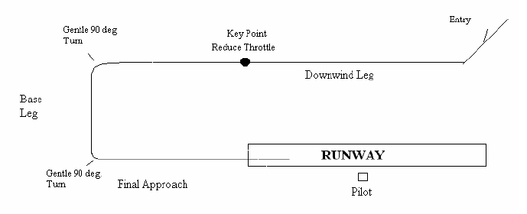

The first part is the pattern entry into the pattern’s first section, or “Downwind Leg”. While shown at a 45 deg. angle in the diagram, entry position is not as critical for RC. Entry can be made from almost any safe angle, even from the runway side (a “crosswind entry”). The plane should complete the entry at about an altitude of 200 feet, at half throttle and located 100-200 feet to the pilot’s right (or left side if the approach is flown from the opposite end, a “Right Hand” pattern). The pilot flies the first part of the Downwind while maintaining straight, level flight. With no wind, the Downwind leg should be about 200 feet out from the runway.

No other piloting task is required during this section, just straight, level flight. When the plane reaches a point opposite the runway end, the Key Point, the pilot reduces throttle to 2-3 “notches” above idle. The plane’s nose will drop some and the plane will begin to descend. The pilot adjusts the descent angle by holding some “up” elevator while the plane is still flying straight. No other task is required at this time except to achieve the proper descent attitude. (Your instructor will help you achieve this attitude the first few times). Again only a single piloting task is required.

The pilot has 150 feet of straight flight to achieve the proper descent attitude. Usually, the fuselage is just slightly pointing downwards in most trainers. If the plane is at the proper attitude, but is descending faster than you would wish, add a notch or two of throttle. Do not raise the nose. Always remember, at any approach airspeed, throttle controls descent rate, elevators control airspeed. Raising the nose will only slow the airplane’s speed due to increased drag and then the plane will descend MUCH FASTER. In fact, it may stall and then really descend faster.

Adding throttle provides extra air under the wing’s center section and also over the tail. The extra lift slows the descent rate but doesn’t really increase airspeed as long as the descent attitude is maintained. This seeming contradiction is harder for RC pilots to comprehend than it is for their full-size counterparts. Full-size pilots have only to feel the increased lift that the throttle provides, and watch their descent meter slow (actually called “rate-of-climb” gauge) while their airspeed indicator remains steady, to understand.

RC pilots just need to try this “up high” a few times at first. Fly past yourself about 250 feet high, at quarter throttle, in a sight descent and apply extra up elevator. Like a car going uphill, the plane gains some altitude but slows dramatically. Then the nose drops and the plane begins a steep descent. Make another pass in a shallow descent and apply a little extra throttle instead of elevator. The nose remains steady but the glide path becomes shallower.

Sorry for the digression, but that concept is important to every RC pilot, especially when flying high performance airplanes. We left the approach with the plane descending slightly and the throttle set 2-3 notches above idle. Next comes a gentle, max. 45 deg. bank, 90-degree turn into the “Base Leg”. The same descent rate is maintained in the turn, add a notch of throttle if required. The turn is only 90 degrees; which is the easiest part of any turn since it is in the second 90 degrees of a turn where the plane slows and starts to drop. Actually this turn is over before the pilot realizes it. Again, just one piloting task is needed at any given time. The pilot only has to maintain straight, descending flight all through the Base Leg.

Then the plane is turned toward the runway with another gentle 90-degree turn. The plane is now headed towards the runway in straight descending flight. If the plane’s touchdown point appears short of the point opposite the pilot, add throttle. If the landing might be past the pilot, called “long”, remove those last 2-3 notches of throttle. Always maintain the descent attitude. If the airspeed appears too fast, add a little up elevator. If the plane is flying too slowly, you’ll notice a very steep approach developing so add throttle and then release some up elevator. On the critical final approach, the pilot is only managing the touchdown point. Everything else has already been accomplished.

Once within 2-3 feet of the ground, just raise the nose slightly with up elevator, keeping everything else the same, and the plane will land main gear first in a straight line, right in front of the pilot. We did this approach with a trainer, but the same technique works for every plane from a scale fighter to a high performance Extra 300.

This all sounds great, but what about the wind? The pattern lets the pilot automatically adjust for crosswinds or for winds right down the runway, without any change in landing management. Consider a wind almost down the runway. All the pilot needs to do is to shorten the Downwind Leg after the Key Point! This shortens the Final Approach, reducing the amount of ground the plane has to cover. Since the plane has a slower ground speed on Final Approach, it covers the shorter distance in the same time. Therefore, the identical descent rate works for wind or no wind conditions (Fig. 2).

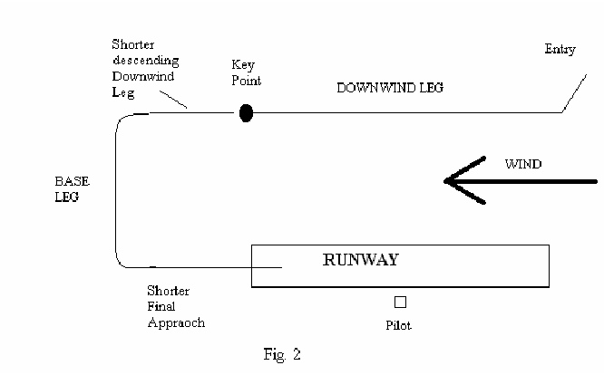
How about a crosswind? Just move the Downwind Leg closer to, or further away from, the runway. This adjusts the length of the Base Leg. A shorter Base Leg reduces the distance the plane needs to fly if the Base Leg heads into the wind.

In Fig. 3, the wind is from behind the pilot. Obviously, the plane’s groundspeed during the Base Leg will be reduced. So the Downwind is flown closer to the runway to compensate for the Base Leg’s reduced ground speed.

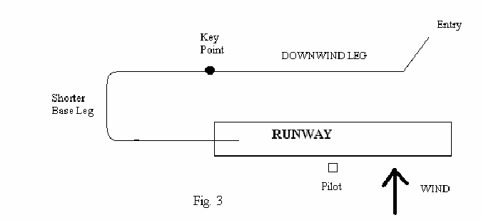

If the crosswind is towards the runway (Fig. 4), fly the Downwind further away. The longer Base Leg compensates for the higher groundspeed. In cases where there is a 45-degree head/cross wind, move the Downwind and adjust its length as required.

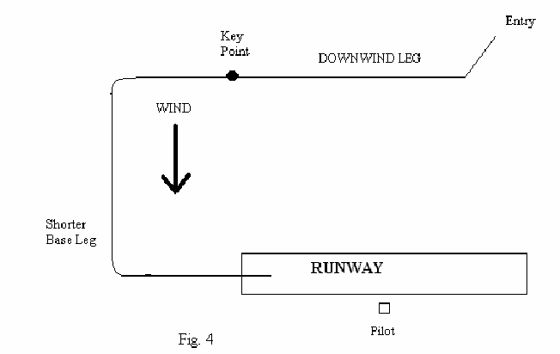
There is one final wind adjustment. In order to compensate for any crosswind component, the plane must be flown headed slightly into the wind, especially on final approach. This has the effect of increasing the ground distance since the plane’s movement is not all directed in a straight line. In this case, reduce throttle to 3-4 notches above idle at the Key Point instead of 2-3 notches. Remember more throttle means a slower descent rate and this compensates for the extra “distance”.

That’s it! The pilot needs to complete only one task at a time, no matter the wind conditions or the aircraft being flown. One size does fit all. Is it any wonder that full size pilots use this pattern? There is even an easy way to teach, or to learn, how to fly this approach. Again, there is only one change required. Raise the Downwind altitude from 200 to 300 feet. The student flies the approach as described. Instead of landing however, the plane crosses the intended touchdown point while still 100 feet high. The student then adds full throttle, climbs back to 300 feet and re-enters the Downwind. As the student becomes better at flying the pattern approach, begin to lower the Downwind’s altitude about 25 feet at a time.

Most times, student pilots make their first landing without even realizing that they are landing! This eliminates the dreaded “fear of the ground” syndrome that affects some students when they see their plane and the ground in their sight picture for the first time. They are down before they even realize what is happening.

In addition, the full-throttle climb recoveries to Downwind altitude teach the student pilots how to do a proper “go-around” or “missed approach” if their landing attempt starts to go the wrong way. The constant approach and climb practice even makes “touch and goes” easier for students to learn.

One other note, what happens if the engine stops during the approach? Anywhere past the Key Point, turn towards yourself, or the middle of the runway, immediately. If short of the Key Point, make a very small standard pattern and land. Trainers glide slowly but do not cover a lot of ground distance in the glide. Apply only enough up elevator to maintain the same descending attitude used on the powered approach. If the plane appears to be landing short of the runway, LOWER the nose (release some up elevator) by about 10 degrees. DO NOT apply up elevator. More up elevator will slow the plane and make it land even shorter. Lowering the nose increases the airspeed and therefore the ground distance covered. Most trainers will make the runway from anywhere in this pattern if the engine quits.

The best landing engine rpm varies with the plane being flown. Most 40-60 sized trainers should be set so that the high trim idle is 2800-3000 rpm on the ground. Moving the throttle trim to half way should result in 2300-2400 rpm. Full low throttle trim should shut the engine off. Fly with the high trim to insure the engine doesn’t quit during the flight. Reduce the trim to halfway just before entering the landing pattern. Shut the engine off before picking up the plane.

GLOSSARY

ABC The composition of an engine piston and cylinder sleeve—Aluminum, Brass & Chrome.
Aileron Control surface on the trailing edge of the wing. It controls roll.
Aliphatic Glue Standard yellow or white glue used to connect wood surfaces. This sets quickly and is sandable.
AMA The Academy of Model Aeronautics.
Angle of Incidence The angle of the wing or stabilizer in relation to the centerline of the fuselage—measured in degrees positive or negative.
Angle of Attack The angle of the wing in relation to the line representing the direction of air movement past the wing. High angles of attack can lead to a stall.
Antenna Either the extendible device on the transmitter or the wire on the receiver intended to radiate or receive radio signals.
Barrel The cylindrical moveable part of the engine’s carburetor. There is a hole through it so that when the barrel is rotated, the amount of fuel and air entering the engine is controlled.
Blind Nut A special T-shaped nut with pointed edges that grip the surface on which it mounted. Mainly used to connect an engine mount to the firewall.
C/A Cyano-Acrylate adhesive. An instant setting glue that is available in thick or thin consistencies. Fumes can cause severe allergic reactions. Use with good ventilation.
Carburetor The device on the engine that mixes and controls the fuel and air.
CG Center of Gravity—the balance point of the model.
Clevis A “U” shaped metal or plastic device that is threaded or soldered onto the end of a pushrod and then connected to a “horn” on a control surface.
Dead Stick Refers to a plane flying and landing after the engine has stopped.
Dihedral The angle that a wing panel has in relation to the horizontal plane.
Dual Rates A switch on the transmitter that allows for two different setting of throws for the control surfaces.
Elevator The control surface hinged to the rear of the horizontal stabilizer. It controls the pitch of the airplane.
Epoxy A two-part adhesive used where extra strength is required. Setting time varies from five minutes to two hours. Allergic reactions can occur.
ESV Expanded Scale Voltmeter—gives an accurate reading of battery charge often with ability to measure under a load.
EZ Hinge A type of hinge used on control surfaces where a simple slot is cut, the hinge is inserted and then secured with thin C/A. Also called C/A hinge.
Firewall The part of the model that supports the engine and separates the engine compartment from the rest of the fuselage.
Flap A control surface located on the trailing edge of the wing inboard from the aileron. It is used on takeoffs and landings to provide additional lift at slow speeds. Flaps add considerable drag and can act as air brakes.
Flight Line The line marked by blocks 20 feet from the edge of the runway where the pilots stand. No one is allowed to stand in front of that line when a plane is in the air without the pilot’s knowledge and permission.
Flight Pack Another name for the receiver battery.
Foaming What happens to your fuel if the tank is exposed to vibration. Fuel tanks need to be isolated with foam rubber.
Four Cycling Describes a two cycle engine that is firing on every other stroke. This is normal at low throttle settings or if the mixture setting is very rich.
Four Stroke Engine An engine designed to fire on every other stroke. It is equipped with valves and pushrods. These engines produce lower RPM than a two stroke engine, but generate higher torque.
Frequency Flag A white flag with the transmitter channel indicated. This needs to be attached to the transmitter.
Frequency Pin A pin for each channel that can be clipped to the transmitter to designate who can turn on their transmitter.
Fuel Filter A small device used to remove small particles for dirt and prevent their entering your engine.
Fuel Proofing Coating the engine or tank compartment with epoxy to prevent raw fuel from soaking into and destroying the wood.
Fuel Pump An electrical, hand cranked or bulb device used to fill the fuel tank.
Fuselage The main body of the airplane.
Glow Battery A 1.2-1.5 V battery used to light the glow plug and keep it hot until the engine is started.
Glow Plug A small device screwed into the top of an engine to ignite the fuel/air mixture.
Ground Crew The members of GCRCC who check out your model and help you get it ready to fly.
Header The connector between the exhaust port of an engine cylinder and the muffler.
Horn A plastic or metal lever that attaches the control surface to the pushrod or servo to the pushrod.
Hot Stuff Brand of C/A
Idle The slow speed of an engine.
Idle Bar A bar attached to the bottom of some glow plugs to improve engine reliability at slow speeds.
Jet Brand of C/A.
Koverall Trade name for heat shrinkable polyester fabric used to cover models. It must be painted.
Landing Pattern The correct way to set-up for landing a plane consisting of three components: Downwind Leg, Base Leg and Final.
Lean The carburetor setting that permits a lower percentage of fuel in the fuel/air mixture. Clockwise on the needle valve. Too lean causes the engine to overheat and possibly to stop running. Can also shorten engine life.
Mixer A means of controlling two servos with just one stick—typically aileron/rudder or flap/elevator. Today, typically accomplished with the computer in the transmitter.
Monokote Trade name for a heat shrinkable plastic film covering that is applied with an iron and/or a heat gun. Many colors and matching paints are available.
P-Factor The leftward turning force on an airplane at a high angle of attack caused by the higher effective pitch on the descending propeller blade (right side) compared to the ascending propeller blade (left side).
Pit Area The area between the spectator fence and the flight line that is designated for the set-up and starting of the models.
Pitch A measure of the angle of the propeller’s blades. Theoretically, a 6 inch pitch propeller would move ahead six inches with each complete revolution.
Power Panel A device that can be installed on your flight box with connections for the electric starter, an electric fuel pump and the glow plug.
Push Rod The means of connecting the servo to the control surface. Usually a plastic or dowel with a stiff wire extended from each end. A wire can be used for the full length if encased in a plastic tube and properly supported.
Reversing Switch A switch located on the transmitter that enables you to reverse the direction of any servo.
Rich The carburetor setting that permits a higher percentage of fuel in the fuel/air mixture. Counter clockwise with the needle valve. Too rich causes an engine to not develop the optimum power.
RPM Revolutions per minute.
Rudder The control surface hinged to the rear of the vertical stabilizer (fin). It controls yaw.
Servo Throw A measure of the amount of movement of a servo. Some radio systems have means to adjust this movement greatly simplifying set-up of control surfaces.
Stall Failure of the wing to provide sufficient lift. This can occur with a high angle of attack and/or a low speed.
Tachometer A device that measures the RPM of an engine.
Tail Dragger An airplane with a tail wheel or skid at the rear of the fuselage.
Thrust Line The angle between the engine crankshaft and the centerline of the fuselage. Right thrust may be used to offset the torque produced by the engine. Down thrust may also be used on some airplanes.
Torque A measure of the rotational power of an engine. A plane responds to the torque generated by a counterclockwise rotating propeller by tending to rotate in the clockwise direction.
Tricycle Gear Landing gear consisting of two main wheels and a nose wheel.
Trim A procedure for making fine adjustments to the control surfaces so that a model flies straight and level with the transmitter sticks in the neutral position. Accomplished by moving the trim levers alongside each control stick. Also used to make adjustments to the idle speed of the engine or kill the engine.
Tuned Pipe A special expansion chamber type muffler that is “tuned” by adjusting the length of the hearer sot that the pressure waves within the pipe are timed to better contain raw fuel within the engine cylinder, thus substantially increasing RPM.
Warp A twist in one or more of the flying surfaces. Warps can cause a model to be unflyable.
Wing Position Location of the wing in relation to the fuselage. High wing—on top of the fuselage. Mid wing or shoulder—just below the cockpit. Low wing—below the fuselage.
Z Bend A “Z” shaped bed in the end of a pushrod wire for connecting to a servo horn. A tool is available for making these bends.

PRE-FLIGHT CHECK LIST
Checked by Ground Crews

Student’s Name__________________________________________________________
AMA Number________________________ GCRCC Member?____________________
Aircraft Description_______________________________________________________
_____ Check for warps
_____ Check for correct Center of Gravity
_____ Check control surfaces for gaps
_____ Check for loose hinges
_____ Check controls for binding
_____ Check controls for correct travel
_____ Check nose wheel for correct travel
_____ Check engine alignment and bolt security
_____ Check propeller nut tightness
_____ Check fuel tank alignment and mounting
_____ Check radio and servo installation
_____ Check receiver antenna is straight and away from servos
_____ Check battery voltage on transmitter and receiver
_____ Check radio range
_____ Check dual rate settings
_____ Check name, address and AMA number are in airplane
_____ Check for spinner or spinner nut
Comments___________________________________________________________
___________________________________________________________________
Flight Check
_____ Climb _____ Stability _____ Slow Flight
_____ Stalls _____ Glide _____ Landing
Comments___________________________________________________________
____________________________________________________________________
INSTRUCTION PROGRAM ELEMENTS

COMMENTS

Reference the number of the Instructional Element being commented on

No | Date | Instructor | Comment

